**SQL STATEMENTS**

1. **On Time %** - Percentage of orders delivered before the promised delivery date.

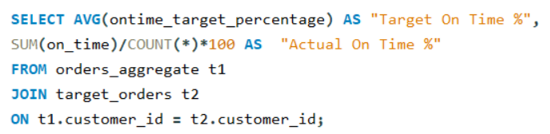 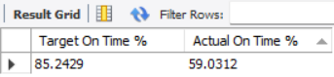

1. **In Full %** - Percentage of orders delivered in full quantity.

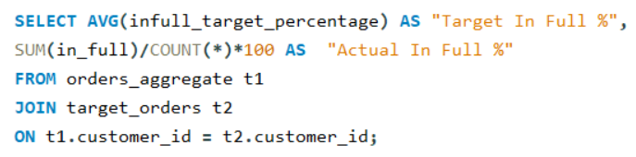

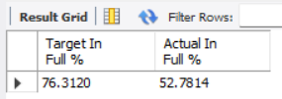

1. **On Time In Full % -** Percentage of orders that were on time and delivered in full quantity.

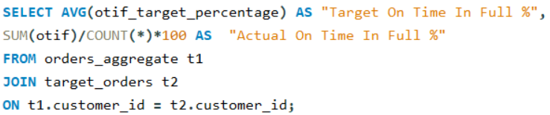

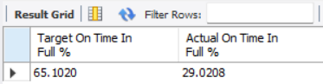

1. **Total Order Lines -** Count of all order lines from all customers combined.

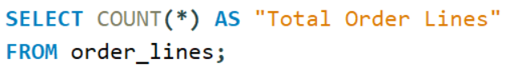

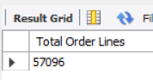

1. **Total Orders**

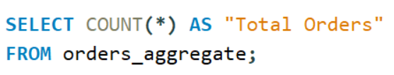

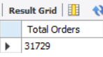

1. **Line Fill Rate -** Percentage of order lines delivered in full quantity.

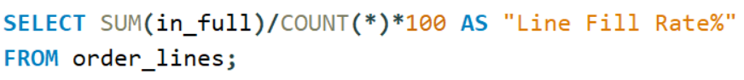

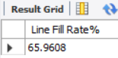

1. **Volume Fill Rate –** Percentage of quantities delivered against the quantities ordered.



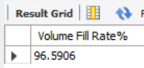

1. **Customer-wise Metrics** – Customer-wise Total Orders, OT %, IF %, and OTIF %.

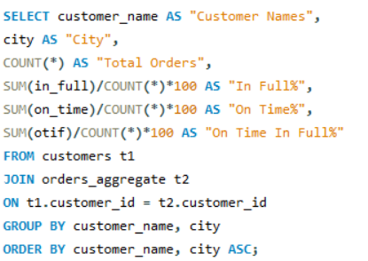

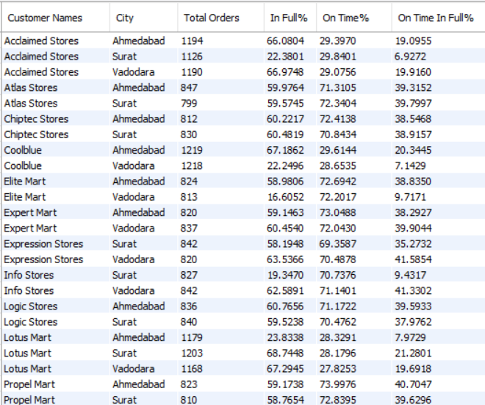

1. **Customer-wise Metrics** – Customer-wise Total Order Lines, Line Fill Rate, Volume Fill Rate

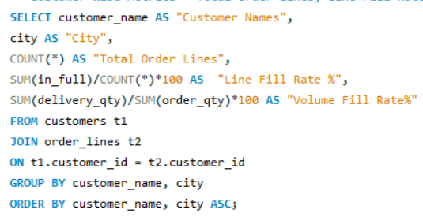

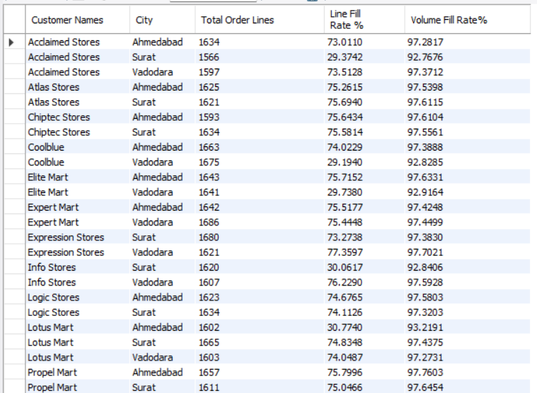

1. **Month-on-Month Trend of metrics –** Month-on-Month Variation of Total Orders, OT %, IF %, and OTIF %.

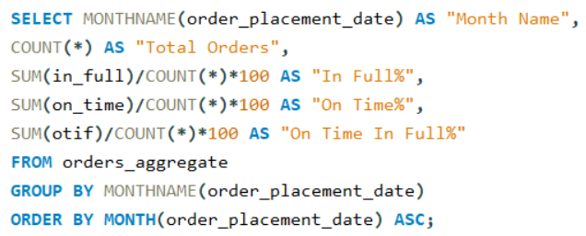

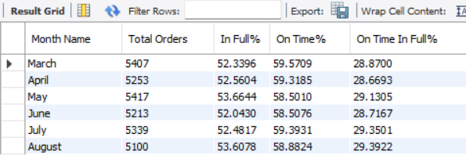

1. **Month-on-Month Trend of metrics –** Month-on-Month Total Order Lines, Line Fill Rate, Volume Fill Rate

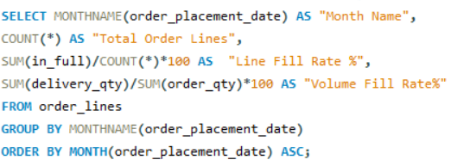

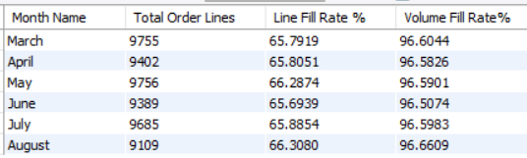

1. **Week-by-Week Trend of metrics -** Variation of Total Orders, OT %, IF %, and OTIF %.

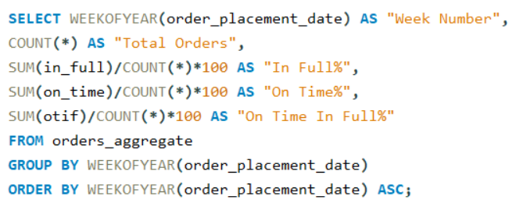

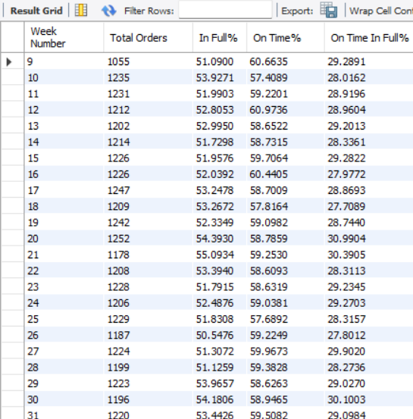

1. **Week-by-Week Trend of metrics -** Variation of Total Order Lines, Line Fill Rate, Volume Fill Rate
2. 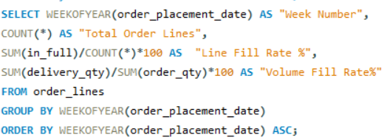

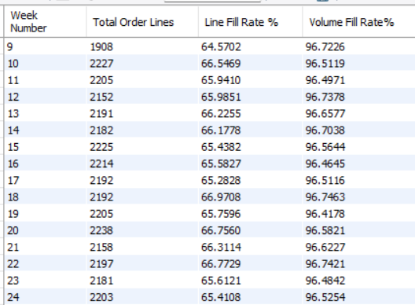

1. **Product Quantity Ordered**

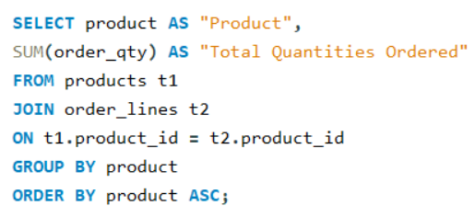

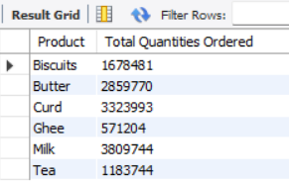

1. **LIFR (Line Full Rate) and VOFR (Volume Full Rate) of Products**

